Gill Owens Scholarship 2025 Research Conclusions- Dr Glen Currie

Introduction
This report was made possible through the generous support of Energy Consumers Australia via the Gill Owen Scholarship. The scholarship enabled firsthand research in California, comparing its energy transition policies, regulatory design, and electrification challenges to those in Australia. With the urgency of climate action and rising energy costs, this research aimed to assess how both jurisdictions are reforming their gas and electricity systems.
The scholarship enabled interviews with energy policymakers, regulators, advocates, and academics in California, as well as a detailed review of transmission reform, electrification planning, and the regulatory frameworks that shape decarbonisation. California, as a global leader in climate policy, provides a valuable reference point. Yet Australia's own reforms — from flexible market design to demand-side participation and state-led gas decommissioning — show strengths that deserve recognition.
This report combines seven articles into thematic chapters covering gas phase-out pathways, rule reform advocacy, equitable electrification, and regulatory innovation. It compares efforts to support vulnerable communities, tackle grid bottlenecks, and plan for precinct-level energy transformation. Each article is presented as a standalone chapter, preserving its references.
Energy Consumers Australia and the Gill Owen Scholarship committee are again thanked for their support of emerging research into consumer-focused energy reform enables cross-jurisdictional learning and helps identify where Australia can lead.

Chapter 1: California’s Shift from Gas to Electricity: Navigating the Challenges of a Clean Energy Transition
California is undergoing a profound transformation in how it powers homes and businesses. For decades, natural gas has played a central role in heating, cooking, and supplying energy across the state. But with growing concerns about climate change, air pollution, and ageing infrastructure, a new vision is emerging—one where electricity replaces gas, paving the way for a cleaner, safer, and more sustainable future.
This transition, however, is complex. It involves legal, technical, economic, and social dimensions that impact everything from monthly energy bills to how quickly solar panels can be connected to the grid. As conversations at Stanford University and beyond reveal, California’s path forward must carefully balance speed, equity, affordability, and resilience.

Why Transition at All?
Natural gas has long been considered a “cleaner” fossil fuel. But mounting evidence shows that it is far from harmless. Gas appliances emit pollutants like nitrogen oxides and benzene, which are linked to serious health problems. Methane, the main ingredient in natural gas, is also a potent greenhouse gas, much more powerful than carbon dioxide in the short term.
Stanford Professor Rob Jackson, a scientist who mapped gas leaks in old gas infrastructure. His research shifted public opinion and policy in record time. Yet today, Jackson and others argue that instead of fixing leaking pipes, a better solution is to reduce reliance on gas altogether.
California has set a target of 100% clean electricity by 2045, and the closure of gas networks is increasingly part of the discussion.

The Legal Landscape
Switching from gas to electricity isn’t just about technology—it’s also about law and governance. Amanda Zerbe, a Stanford Law School Fellow and expert in climate planning, pointed out that last month a Judge supported a State of Washington natural gas measure that had been challenged by he fossil lobby. That decision upheld the power of local governments to plan their clean energy futures—a promising signal for cities in California that are trying to ban gas in new buildings.
Still, California’s “obligation to serve” law, which requires utilities to continue supplying gas to any customer who wants it, complicates the picture. This legal obligation creates friction with the push for electrification and could delay or increase the cost of transitioning away from gas.

Costs and Inequities in the System
One of the biggest concerns in the transition is affordability. Lane Smith, at Stanford Woods Institute for the Environment, researching energy equity, highlighted how some households in California’s hotter climate zones pay up to $200 per month more than the average bill. His research suggests that rising costs are being driven by several factors: wildfire prevention, the expansion of the grid to support electrification, and the ongoing maintenance of infrastructure that is, in many cases, 70 years old.
Another cause of electricity bills rising is how solar customers are charged. Because many solar owners use less electricity from the grid, they also pay less toward maintaining it. This has parallels with what could happen on the gas side—if fewer people use gas, the remaining users could see their bills soar, simply because there are fewer people left to share the fixed costs of the system.

Technical Bottlenecks
Switching from gas to electricity means more than swapping out appliances. It often requires upgrading household circuits from 100 amps to 200 amps and running new wiring. In California, this can cost thousands of dollars and takes time—PG&E, for example, takes 2–3 months just to approve a circuit upgrade, and the work itself sometimes costs $4,000 or more.
Meanwhile, California’s solar industry is facing delays due to required grid studies and bottlenecks in connecting new systems. California street-level electricity transformers are much smaller than those in Australia, meaning fewer homes can be connected before upgrades are needed.
Efforts to streamline this process are underway. Sacramento’s municipal utility has automated some of the solar approval steps, and Texas has taken a different approach by allowing solar customers to proceed without waiting for grid studies, though the customers accept the risk of being curtailed during peak times.

The Bigger Picture: Planning and Policy
Mareldi Paras, a researcher at Stanford Woods Institute for the Environment, emphasised the importance of planning for resource adequacy—that is, making sure the electricity system can handle increased demand when gas is phased out. This involves careful modelling, as researchers like Professor Adam Brandt at Stanford are doing, to ensure the transition won’t lead to blackouts or reliability issues.
California is also considering introducing new electricity rate structures. These would provide clearer price signals to encourage people to shift their energy use to times when renewable energy is most abundant, like midday, when solar output is high. Ahmad Faruqui, an energy economist, has been critical of the current system, which he says doesn’t do enough to reward smart energy use.
On the other hand, Severin Borenstein at UC Berkeley has long argued that small-scale solar is too expensive compared to large-scale renewables, and Severin supports higher fixed monthly charges to reflect the true cost of grid services.

Can We Really Shut Down Gas in 10 Years?
A popular idea among researchers is to set a 10-year window for closing down household gas systems. The math is simple: if 4% of water heaters and 3% of space heaters are replaced with electric models each year, most—but not all—homes could be electrified within a decade. This gives time to upgrade supply lines, train gas workers for new jobs, and create financing options that make the switch easier for consumers.
There are additional issues in areas where residential and industrial gas users are mixed. For residential areas it would be ideal if policy could motivate gas companies to plan for their shutdown, rather than resisting the inevitable.

California and Australia: Learning from Each Other
California isn’t alone in this journey. Australia is facing many of the same challenges, but has some key differences. Retail electricity prices in Australia are about $A0.20 per kWh versus California’s $A0.40, and gas in Australia is more expensive, making the case for electrification in Australia more compelling. Over 30% of Australian homes already have rooftop solar, and in places like South Australia, renewable energy has already hit 100% on some days so the electrification of homes is even more economic with the zero marginal cost energy supply from their solar systems.
There’s growing interest in collaborative research between Australia and California to share lessons, especially around issues like wildfire hardening, equitable access to clean energy, and managing the economic risks of tariffs and regulation, and a 2023 MOU supports this.

Looking Ahead
The transition from gas to electricity in California won’t happen overnight, but it is moving forward. With the right planning, clear policies, and a focus on fairness, it is possible to build a cleaner, safer, and more resilient energy system. But the success of this transformation depends on facing tough questions, listening to diverse voices, and learning from both local and global experience.
As California reshapes its energy future, the choices made today will echo for generations to come. The electrification rationale for California is shown in the following infographic.
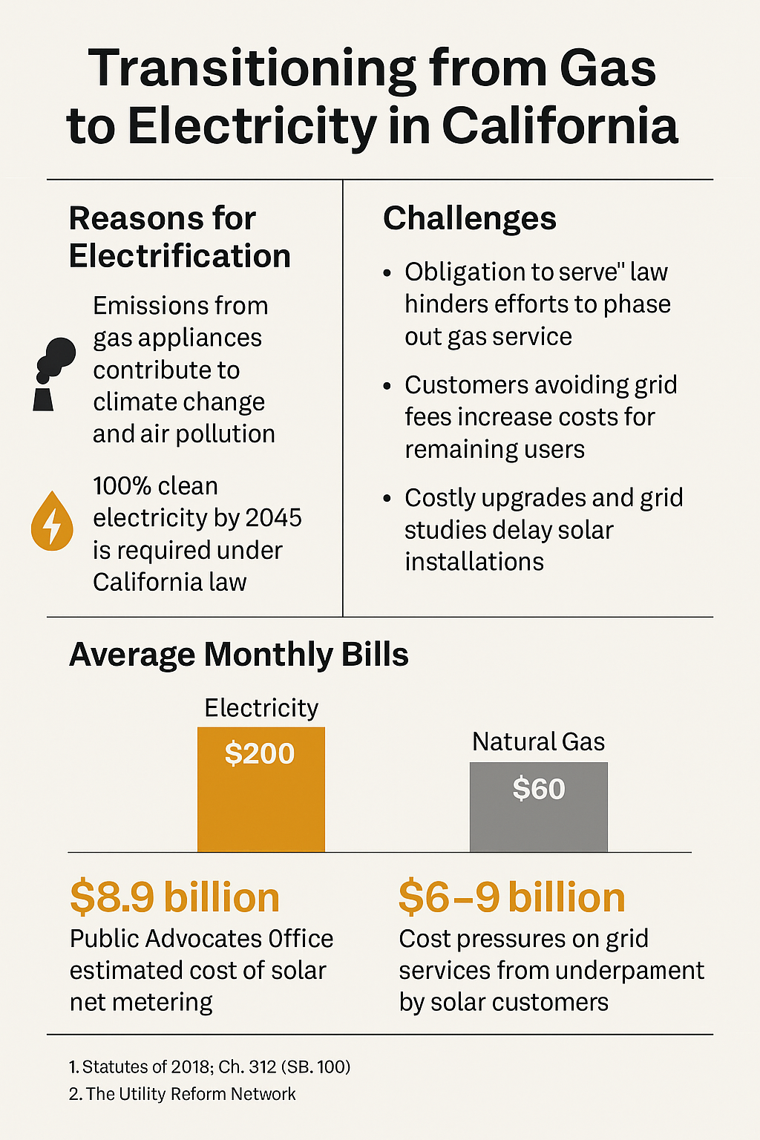
References
[1] Australian Energy Statistics | energy.gov.au
[2] Historical Electric Cost Data - California Public Utilities Commission
[3] California Energy Consumption Dashboards
[4] Australia Electricity Prices - CEIC Data
[5] Chart: Australian Energy Prices Keep on Climbing | Statista
Further reading
- Washington ruling that local governments can decide on their gas bans
- MOU between California and Australia on Clean Energy

Chapter 2: Why Is Energy in California twice Australian costs? — And What Can We Learn From It?
Californians pay some of the highest utility bills in the United States — with electricity prices reaching $0.48 AUD per kilowatt-hour in some regions and monthly energy bills around $280 AUD. While wildfires and aging infrastructure certainly contribute, experts point to deeper structural and political drivers. As Australia debates its own gas-to-electricity transition, California’s experience offers both cautionary tales and policy inspiration.
Monthly Household Energy Bills (AUD, Median)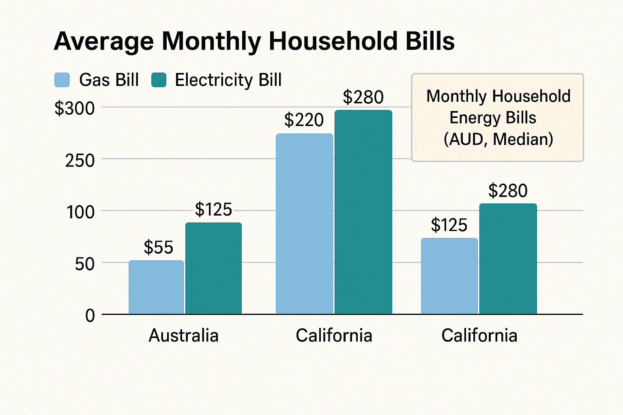

- Median retail electricity price (2023):
  - California: $0.48 AUD/kWh
  - U.S. national: $0.26 AUD/kWh
  - Australia: $0.27 AUD/kWh
- Median monthly household energy bills:
  - California $280 AUD (electricity), $220 AUD (gas)
  - Australia: $125 AUD (electricity), $55 AUD (gas)
- Cost drivers:
  - Wildfire mitigation spending in California: $61B+ AUD across major utilities
  - Rooftop solar cost to the Californian system: Up to $13.7 billion AUD annually (PAO Est.)

Historical Price Comparison: California vs Victoria
Understanding how California stacks up globally requires a comparison with similar jurisdictions like Victoria, Australia — which also faces the challenge of transitioning from gas to electricity amid volatile energy markets.
California electricity and gas prices have shown long-term upward trends due to policy, infrastructure, and market factors. Meanwhile, Victoria has also experienced rising prices, although moderated by stronger national regulation and more robust grid interconnection.

After Enron: A State Disconnected
A major, often overlooked factor in California’s high electricity prices is the state’s limited integration with the broader U.S. grid. In the wake of the Enron scandal in the early 2000s — where energy market manipulation triggered price spikes and blackouts — California regulators locked down local electricity markets and restricted interstate power trading.
But those protections now come at a steep cost. California cannot easily import cheaper electricity from neighboring states, even when it’s abundant. Lil Kohrman-Glaser of 350.org USA calls this isolation a key structural flaw: “The high prices in California are partly due to the lack of interstate interconnects, and utilities tend to be behind many of these perverse outcomes.”
In contrast, other parts of the U.S. participate in integrated regional transmission organizations (RTOs) that allow for load balancing and shared grid costs, which helps suppress price volatility.

California’s Power Problem (AUD)
- Poor Grid Connectivity: Limited interstate trading keeps cheap power out
- Aging Infrastructure: Some grid components are 70+ years old
- Wildfire Mitigation: $15B+ AUD annually in hardening costs
- Rooftop Solar Cost Shift: Grid maintenance shifted to non-solar users. About $10 billion AUD annually.
- Limited Market Reform: Resistance to joining multi-state markets

Utilities, Wildfires, and Profit Pressures
The role of investor-owned utilities (IOOs) in California’s energy market adds further complexity. Utilities like PG&E, SDG&E, and SoCal Edison operate as regulated monopolies — but with obligations to investors that often conflict with affordability goals.
The state’s devastating wildfire seasons have prompted billions in spending on undergrounding power lines and grid hardening. These costs — estimated at over $61 billion AUD — are passed directly to consumers. Yet, as Kohrman-Glaser points out, “One in ten people in the U.S. can’t afford their utility bill,” even as utility shareholders continue to profit.
Adding to the burden are net energy metering (NEM) policies. While rooftop solar supports decarbonization, early versions of California’s NEM policy allowed solar users to avoid paying their share of grid maintenance. According to the Public Advocates Office (PAO), this led to a cost shift of $9–$13.7 billion AUD annually from solar to non-solar households — an imbalance only partially corrected by new regulation called NEM 3.0.
There is a further cost burden from Community Choice Aggregators (CCAs) which buy electricity on behalf of local communities because they operate independently of utilities but still rely on utility infrastructure and coordination issues have emerged between CCAs and the California Public Utilities Commission (CPUC) and these have slowed planning.

Electrification Faces Political and Market Headwinds
California has led the U.S. in climate policy, but electrification of homes and buildings has been slowed by political resistance and economic misalignment. Kohrman-Glaser highlights this challenge: “There’s a lot of political and gas lobby resistance to electrification.”
Cold-weather states, in particular, resist mandates due to concerns about heat pump reliability and electric grid stability during peak winter demand. Even within California, regional climate, building stock, and utility planning timelines complicate rapid adoption.
Crucially, California lacks a clear, enforceable gas retirement date — something jurisdictions like the ACT and Victoria in Australia have committed to. In the U.S., regulatory change often relies on nudges, subsidies, and pilot programs rather than mandates or centralized workforce planning.

Australia’s Comparative Edge
- Interconnected grid across states
- National appliance efficiency standards
- Victoria’s ban on gas in new homes (2024)
- Clearer gas closure targets
- Lower rooftop solar costs: ~$1.50 AUD/W vs. California’s $9 AUD/W

Bright Spots in Policy Innovation
California has introduced innovative programs that could offer useful templates for Australia. For example, the Zero Emission Vehicle (ZEV) mandate helped create a tradable market for EV sales credits — a policy that catalyzed Tesla’s early growth and is now adopted by more than a dozen U.S. states. A similar approach could apply to appliances: mandating electric hot water or space heating targets with compliance via certificate trading. But such schemes would require a robust appliance registration system — something Australia may be better positioned to implement due to stronger federal governance.
Other examples of policy creativity include:
- Southern California’s water heater credit proposal, where gas water heater sales trigger a fee and electric models generate credits
- Vermont’s proposed Clean Heat Standard, where fuel suppliers must purchase clean heat certificates or invest in electrification
Vermont’s bill was ultimately blocked, but their concept remains compelling.

Learning From California’s Complexity
Electricity in California is expensive because of cumulative structural flaws — not one bad policy. Protectionism, poor market connectivity, utility profit incentives, and fragmented governance all play a role.
California’s attempts at reform — from SB 1221’s precinct electrification to advanced behavioral programs like Oracle’s Opower — show what’s possible, but also reveal how hard systemic change can be.
Meanwhile, utilities are slow to change. In PG&E’s own long-term electrification roadmap, the company estimates a 50-year transition timeline, with continued gas service to residual customers, industry, and backup services. To bridge that gap, they propose reliance on Renewable Natural Gas (RNG) and carbon capture — both costly and uncertain technologies.

Final Thoughts: Designing for Equity and Simplicity
What can Australia learn?
- Avoid overengineering the grid. California’s grid is expensive in part due to excessive complexity and piecemeal reforms. Australia’s more centralized energy planning system offers a chance to plan holistically.
- Mandate simplicity. Rather than layering electrification incentives, set clear rules — such as banning new gas in buildings, aligning appliance standards, and creating finance schemes for electric upgrades.
- Protect the vulnerable. Cross-subsidies must be fair. The Californian rooftop solar story is a cautionary tale about good policy gone regressive.
- Keep markets open. Avoid protectionist reflexes. An interconnected grid — as Australia’s National Electricity Market (NEM) already enables — unlocks huge efficiency gains.
“California’s electrification push is bold, but it’s also bogged down by its own history,” says one policy analyst. “It’s up to others to learn from that and design cleaner, simpler pathways.”

Further Reading
- Public Advocates Office on Solar Cost Shifting
- California Energy Commission
- California Public Utilities Commission
- 350.org USA
- Oracle Opower
- TECH Clean California
Climateworks Centre - Australia's Energy Transition

Chapter 3: California's Bold Gas Transition: The Roadmap, the Risks, and the Realities of SB 1221
California is taking a lead in climate and energy policy with Senate Bill 1221 (SB 1221), a law designed to transition the state away from gas infrastructure and toward targeted electrification. At the heart of this ambitious effort is a mix of policy innovation, regulatory engineering, and the deeply practical challenge of mapping and managing the future of energy delivery at the neighborhood level.
Backed by years of analysis and pilot programs, SB 1221 enables utilities to shut down ageing gas pipelines and replace them with electrified heating and cooking infrastructure — if doing so is cheaper than replacing the gas pipe. The legislation requires the California Public Utilities Commission (CPUC) to negotiate the implementation details with utilities like PG&E, which have been quietly electrifying communities. According to David Sawaya of PG&E, “We’ve been electrifying customers on some branch lines for seven years, and our policy is that 100% of customers must buy in. Only 30% of projects therefore get the go-ahead.” In contrast, SB 1221 allows the gas companies to electrify with just 66% of customers on that line buying in.
A Bill with Big Stakes
Co-authored by Beckie Menton of the Building Decarbonization Coalition and implemented with support from CPUC staff like Arthur Fisher, SB 1221 marks a major shift in California’s approach to utility obligations. Arthur Fisher notes, “The act is legislated, so the CPUC is now negotiating the mechanism via a process in front of the commissioners.” This includes rethinking the long-standing "Obligation to Serve" — a policy that has led to costly and counterproductive investments in gas infrastructure.
The bill’s key innovation lies in enabling non-pipeline alternatives (NPAs) to traditional gas line replacement. According to CPUC and NRDC's Kiki Velez, electrification projects under SB 1221 can only proceed if they directly save money for gas customers — by avoiding the cost of new pipeline construction. “These projects can be paid for using the avoided gas pipeline costs while delivering the savings back to customers,” Velez explains.
The Mapping Mandate
One of the most technically complex — and politically sensitive — parts of the bill is its mapping requirement. As Arthur Fisher says, “The map must be submitted by July 2025 and focused on pipe replacement.” Public Utilities Code 661(a) mandates that each gas corporation submit detailed maps annually, showing where gas infrastructure is planned for replacement, and overlaying this with city, county, and census tract boundaries, as well as disadvantaged communities and designated decarbonization zones.
But this mapping has become a sticking point. Rachel Wittman of PG&E, who is overseeing implementation of SB 1221 at the utility, noted that PG&E has already spent four to five years building a GIS-based Geospatial Electrification Tool. “It includes pipe locations, customer bills, fire risk, and upcoming gas work. This should be adequate for optimization in planning.” PG&E prefers that the CPUC adopt its existing mapping methodology, rather than require a completely new framework.
Forcing the Final Third?
One of the most politically charged components of SB 1221 is the mechanism for securing customer participation. While PG&E historically only proceeds with electrification when 100% of customers agree, SB 1221 sets the bar at 66% agreement, leaving the potential for one-third of customers to be “forced” off gas.
Fisher acknowledges the challenge. “Politically, I'm not sure the CPUC would enable a project to move forward with a full one-third of customers objecting.”
Potential solutions include partnering with community-based organizations for outreach, offering free home electrification to sweeten the deal, and allowing holdouts to use backup fuels like propane. But even internally, PG&E concedes it lacks a definitive answer for compelling reluctant participants.
Who Pays for the Transition?
SB 1221 has sparked important debates about cost allocation. At issue is whether electrification upgrades — though cheaper than gas pipes — should be treated as capital assets that earn a regulated return for utilities. PG&E’s proposed CSU Monterey Bay project was withdrawn partly due to disagreement on this point.
As Velez explains, “Almost all stakeholders in California support having the gas utility pay for cost-effective targeted electrification projects. The debate is whether the utility should earn a rate of return.”
The bill is ambiguous on whether these costs should be capitalised. Arthur Fisher and Richard Khoe at CPUC stress that targeted electrification should not burden ratepayers long-term. Assets would be depreciated over shorter periods than gas pipelines, delivering near-term savings.
A Patchwork of Progress
California isn’t alone in confronting the future of gas. NRDC tracks similar efforts in Colorado, Washington, Illinois, New York, and New Jersey. California’s legislation builds on that momentum with more specific mandates and a stronger focus on affordability.
Meanwhile, affordability remains a critical concern. As one community energy aggregator pointed out, “One in ten Californians can’t afford their utility bill.”
Electricity prices are high in California due to wildfire mitigation, old infrastructure, and limited interstate transmission. Distribution costs have surged as utilities harden the grid against fires. The state’s reliance on demand response for summer peaks means prices can spike to $1000/MWh. Gas, by contrast, remains cheap at $3–5 per MMBtu, making the switch harder to sell in the short run.
The Broader System
CPUC handles modeling for resource adequacy and environmental targets, while the California Energy Commission (CEC) leads forecasting and plant licensing. But a disconnect exists between centralized regulators and Community Choice Aggregators (CCAs), who independently procure energy and set local goals.
Some stakeholders — like Clare Holbrook, formerly of PG&E and now at Gridworks — are pushing for improved coordination. Matthew Tisdale, Gridworks’ CEO, has backed initiatives that bridge utilities, regulators, and communities.
The investor-owned gas utility landscape includes PG&E, San Diego Gas & Electric (SDG&E) and Southern Californian Gas (SoCalGas). PG&E serves Northern and Central California, while SoCalGas primarily serves Southern California, and SDG&E serves San Diego County and parts of Orange County. Southwest Gas also provides natural gas distribution in the Lake Tahoe area. The City of Los Angeles runs its own municipal utility for both power and water.
Where to Next?
With a July 2025 deadline looming for the first set of utility maps, the next months will be critical. Rachel Wittman’s PG&E team is expected to publish an economy-wide net zero study showing electrification as the lowest-cost path — but also projecting a 50-year timeline for full transition, with continued need for renewable gas and carbon capture in certain sectors.
And yet, even with legislative authority, technical mapping, and PG&E’s seven years of field experience, questions remain. How do you compel the last holdouts? Should utilities profit from electrification? What’s the right balance between privacy and planning?
As California moves into implementation, the answers will shape the national conversation — and possibly offer models for Australia, where similar debates are emerging.
As Beckie Menton, one architect of SB 1221, and Kiki Velez at NRDC continue to engage stakeholders and fine-tune policy, California once again finds itself as a climate laboratory — experimenting with the tools, incentives, and politics of a post-gas world.

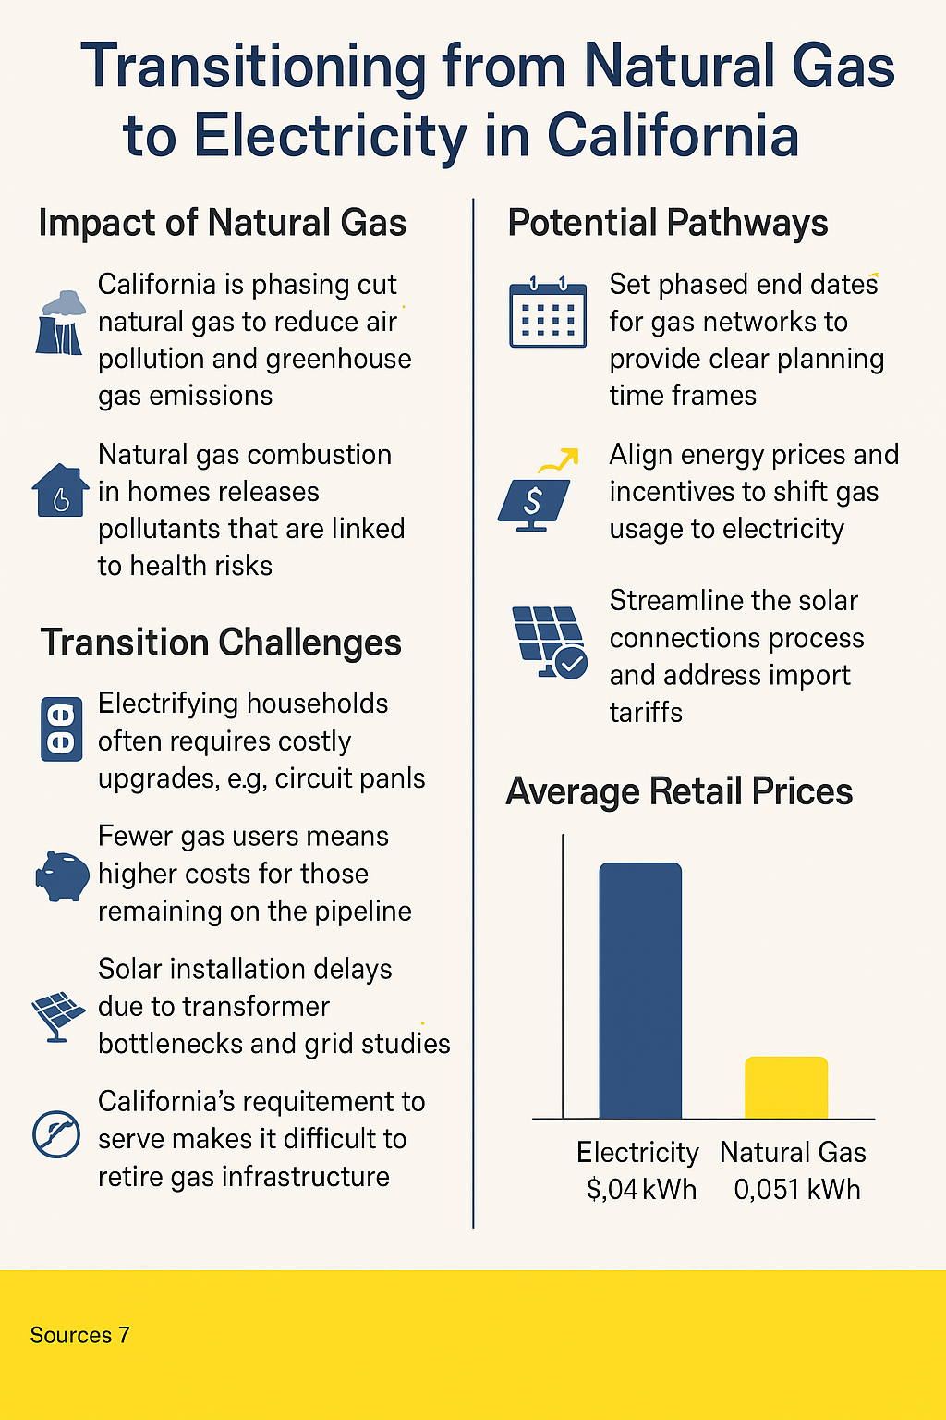
Further Reading:
- NRDC on SB 1221
- CPUC SB1221 Workshop
- NRDC on CO’s Gas Planning
- State Progress Report
- SB1221 full text
- CARB Zero-NOx standards
- Building Decarbonization Coalition
- 350.org USA
- PG&E Electrification Mapping Tool

Chapter 4: Berkeley's Gas Ban Reversed: What It Means for Local Climate Action in California
In 2019, the City of Berkeley made headlines as the first jurisdiction in the United States to ban natural gas infrastructure in new buildings. The city had hosted a public electrification forum earlier that year, led by Councilmember Kate Harrison, and momentum built quickly around local climate action. Berkeley’s groundbreaking policy kicked off a cascade of similar local ordinances across California and the country, galvanizing a new front in the climate fight: building electrification.
But in January 2024, the gas ban was reversed following a lengthy legal battle brought by the California Restaurant Association (CRA), marking a setback not only for Berkeley but for other cities that hoped to lead on climate via local policy. The reversal has triggered resignations, new legislation, and broader debates about state and federal preemption. It has also highlighted the limits of municipal authority in governing energy.

A Legal Saga
The policy’s origin goes back to February 2019, when Berkeley hosted an electrification forum to engage residents, experts, and businesses. Councilmember Harrison championed the policy that would ban gas hookups in new buildings, an unusual move given that typically, city staff propose regulations before council votes. In July 2019, the city passed the ordinance — the first of its kind — sparking immediate backlash.
By late 2019, the CRA sued the City of Berkeley, claiming that the ordinance was preempted by the federal Energy Policy and Conservation Act (EPCA). The EPCA regulates energy efficiency standards for appliances, and the CRA argued that banning gas infrastructure effectively limited consumer access to federally approved appliances.
Initially, the case leaned in Berkeley’s favor. In January 2020, the ban was implemented at the point of planning permits. A district court upheld the rule, supported by numerous legal briefs including one from the U.S. Department of Energy (DOE). But in a surprising turn, the Ninth Circuit Court of Appeals reversed the decision in April 2023, siding with the CRA. The court ruled that Berkeley’s policy amounted to an indirect ban on gas appliances, violating federal law.
In January 2024, Berkeley officially rescinded the gas ban. Councilmember Harrison resigned shortly thereafter.
"This ruling has cast a long shadow on the authority of local governments to lead on energy transition," said Sarah Moore, the City of Berkeley’s Climate Action Coordinator.

Sidebar: Timeline of Key Events
- Feb 2019: Berkeley holds an electrification forum
- July 2019: Berkeley passes gas ban ordinance
- Nov 2019: California Restaurant Association files lawsuit
- Jan 2020: Gas ban implemented via planning permits
- 2021–2022: Federal district court rules in favor of Berkeley
- April 2023: Ninth Circuit reverses decision
- Jan 2024: Ban overturned; Councilmember Harrison resigns

Statewide Ramifications
The implications of the court decision are already rippling through California’s energy landscape. In response to both the Ninth Circuit ruling and growing wildfire threats, state lawmakers introduced Assembly Bill 306 (AB 306). The bill proposes to freeze updates to California’s building code until at least 2031 and limits the authority of local governments to impose stricter standards. They argue that wildfire rebuilding needs less change in building regulation to keep costs down.
This represents a significant shift. Under existing rules, municipalities could go beyond state code if justified by local conditions, such as seismic risk or climate vulnerability. AB 306 would eliminate that flexibility.
The bill is seen by critics as a capitulation to fossil fuel interests and a rollback of hard-won local environmental powers.
"California cities were acting because the state was too slow. Now, the state is moving to silence those very cities," said a policy analyst at ICLEI — Local Governments for Sustainability, an international network of cities.
Regulatory Freeze Ahead?
As if the legal hurdles weren’t enough, a new state law — AB 306 — could further restrict local government authority over building codes. The bill, partly driven by concerns about wildfires sparked by electrical infrastructure, proposes freezing California’s building code updates until at least 2031 and would preempt local enhancements to state code.

Historically, cities like Berkeley had the flexibility to adopt stricter codes in response to local needs. AB 306 would block that.

Sidebar: What Is AB 306?
- Would freeze California building codes until at least 2031
- Prohibits local governments from setting stricter standards
- Motivated by concern over wildfire risks and electric reliability
- Currently progressing through the Californian Senate

Federal Complications
On April 8, 2024, an executive order titled "Protecting American Energy from State Overreach," was signed and directs federal agencies to curtail state and local regulations that restrict fossil fuel infrastructure. Though its future under legal challenge is uncertain, the order adds another layer of complexity for California municipalities trying to enact climate-forward policies.
Legal experts note that the EPCA, which the Ninth Circuit invoked in the Berkeley case, has become a new tool for industry groups to challenge decarbonization efforts. The law, passed in the 1970s, was an energy efficiency intent and was not designed to block local climate policies — but in today’s polarized environment, it’s being weaponized to do just that.

A New Era of Energy Governance
The Berkeley saga underscores how local initiatives are increasingly colliding with state and federal structures. In Alameda County, which includes Berkeley, the transition to clean energy is also being pursued through the local Community Choice Aggregator (CCA), Ava Community Energy (formerly East Bay Community Energy). CCAs allow cities and counties to procure renewable electricity on behalf of their residents, bypassing traditional investor-owned utilities.
But even CCAs are limited. While they can choose energy sources, they don’t own distribution infrastructure or set building codes. To go all-electric, cities need control over land use and appliance rules — and those are now under threat.

Looking Ahead
Despite the setbacks, advocates remain committed to electrification as a key climate strategy. All-electric buildings not only reduce emissions but also improve indoor air quality and safety. Groups like the Building Decarbonization Coalition and NRDC continue to push for state-level solutions, such as SB 1221, which enables utilities to replace gas infrastructure with electrified systems when cost-effective.
Berkeley's experience serves as a cautionary tale about the fragility of local climate authority — but also as a case study in persistence.
"Cities will need to coordinate more than ever with the state to navigate legal barriers and keep moving toward decarbonization," Moore said.
The road ahead may be harder, but the goal — a safe, clean, and equitable energy future — remains unchanged.

Further Reading:
- Berkeley’s original gas ban article
- Ninth Circuit ruling
- AB 306 bill text
- Ava Community Energy
- ICLEI USA

Chapter 5: Advocacy and the Energy Transition: How the US and Australia Are Pushing for Rule Reforms
As the climate crisis accelerates and energy costs rise, the pressure to reform energy policy is mounting. Advocacy groups on both sides of the Pacific are working furiously to reshape the rules that govern how we heat our homes, power our industries, and structure our electricity and gas markets. From Berkeley to Sydney, grassroots organizers, nonprofit policy analysts, and state officials are collaborating to guide a just, affordable, and rapid transition away from fossil fuels.
This article explores the contrasting advocacy strategies in the United States and Australia, based on interviews with policy leaders and documents from electrification think tanks.

Key Advocacy Targets in Energy Rule Reform
- Building codes
- Electrification subsidies
- Gas infrastructure planning
- Peak demand management
- Community-level data transparency
- Rate design and tariff structures

The U.S. Strategy: Integrated Advocacy in a Fragmented Landscape
Zach Pierce, Senior Director of State & Regional Policy at Rewiring America (RA), describes the group’s mission as part community education, part regulatory push. RA has emerged as one of the most visible electrification advocates in the United States, operating across states like California, Oregon, Colorado, Massachusetts, and New York.
RA's toolkit includes:
- A personal electrification planner and ZIP-code-specific calculator used over 1 million times
- A best-in-class API to model bill impacts and NOx emissions
- Advocacy partnerships with groups like Sierra Club and Earthjustice
"We have to address both the household costs and the system costs of electrification," says Pierce. "That means subsidies, but also smarter regulation."
RA’s position is clear: energy rules must evolve to reflect new realities — and opportunities. In states like California and Colorado, where Public Utility Commissions (PUCs) are leading on integrated gas and electric planning, RA supports changes like:
- Mandating building electrification in new construction
- Supporting Virtual Power Plants (VPPs)
- Reforming time-of-use tariffs
- Encouraging utilities to finance electrification
Their API and data cube are increasingly used to inform policymaking, with models that consider emissions, household bills, and energy use.
Zach Pierce, Rewiring America opined "In states where the economics are tough, we lean on better building codes and push for affordability solutions. We believe utilities can help fund this transition — they just need the right incentives."

Australia’s Approach: Stakeholder Roadmaps and State-Led Workshops
On the other side of the globe, Australian advocacy efforts focus on collaborative policy development, data transparency, and roadmap design. A recent workshop hosted by RACE for 2030 and the NSW Department of Climate Change, Energy, the Environment and Water (DCCEEW) exemplifies this strategy. The workshop aimed to build a gas decarbonisation roadmap informed by real data — and the community’s voice — to guide our state’s transition over the coming decades.
The workshop brought together experts from CSIRO, ClimateWorks Centre, FutureFuels CRC, and Energy Consumers Australia to map the decarbonisation pathway for residential, commercial, and industrial gas users in New South Wales.
The challenge? Identifying least-cost pathways that maximize public benefit. This requires understanding:
- Gas usage at the most granular level
- Disaggregated gas data across sectors (e.g., asphalt, glass, hospitals, mixed-use buildings)
- Peak vs. average gas loads
One insight from the workshop: the electrification of industry and buildings could significantly reduce residential energy bills — but only with robust modeling and phased implementation.
Bridging Two Models: Shared Lessons and Divergent Risks
While Rewiring America prioritizes tools and rapid policy activation, Australian advocates tend to focus on consensus-building and cross-sector collaboration. Both strategies have merit, but also distinct weaknesses.
In the U.S., politics can halt progress. The Berkeley gas ban case, overturned by a conservative 9th Circuit court, showed how even leading-edge municipal action can be stifled by federal preemption. Meanwhile, Australia’s federated system allows for state experimentation, but with patchy implementation and slow national alignment.

Country | Key Advocacy Model | Main Barriers | Focus Areas
USA | Tech + Legal + Grassroots | Federal preemption, affordability | Incentives, VPPs, codes
Australia | State roadmaps + modeling | Data gaps, uneven jurisdiction | Decarb pathways, peak usage

What’s Next?
In both countries, advocates agree: the grid of the future must be cleaner, smarter, and more affordable. That means accelerating the shift to electricity while ensuring no one is left behind.
In the U.S., Rewiring America plans to deepen its work on rate reform and expand its API use into new state regulatory filings. In Australia, modeling and roadmaps are expected to inform future legislation and incentives.
“It’s not just about switching fuels,” says Glen Currie from ClimateWorks Centre. “It’s about remaking the system to be more human, more equitable, and more data-driven.”
As energy rules evolve, the advocates behind them are shaping more than kilowatt-hours — they’re writing the code for climate justice.

More Resources
- Rewiring America
- ECA Gas Report
- ClimateWorks: https://www.climateworkscentre.org

Chapter 6 Caught in the Crossfire: Utilities and the Turbulent Road to Energy Transition
As governments, regulators, and climate advocates advance clean energy targets, electric and gas utilities are being asked to shoulder unprecedented transformations. Behind the promises of heat pumps and grid interactivity lies a logistical, financial, and regulatory tangle for utilities, many of which are grappling with aging infrastructure, uncertain customer demand, and incompatible business models.
Nowhere are these tensions clearer than in California. Utilities like PG&E are facing a convergence of decarbonization mandates, rising costs, and shifting expectations — all while still recovering from the legacy of deadly wildfires, bankruptcies, and public mistrust.

The Uneven Economics of Electrification
At the heart of utility unease is a fundamental mismatch between electrification goals and existing financial structures. Electrifying customers may align with climate targets and long-term planning, but it also requires costly upfront investment — often with paybacks that span decades.
A case in point is PG&E’s proposed electrification project at CSU Monterey Bay. The utility hoped to recover not just the project cost but also the opportunity cost of using its capital — an amount that was modest, and with no profit margin attached. But the proposal was rejected, largely due to opposition from ratepayer advocates concerned about adding costs to consumer bills.
“We weren’t asking for profit,” a PG&E representative explained, “but the cost of capital has to come from somewhere. Using company funds for electrification competes with everything else we’re expected to fund — wildfire mitigation, grid upgrades, customer service.”
This conflict underscores a growing problem: utilities are being asked to lead the energy transition without regulatory clarity on how they will be compensated — or protected — as their business model shifts.
The Utility Capital Conundrum
- Traditional cost recovery = guaranteed rate of return on capital investment
- Electrification = may not qualify as a capital asset under current rules
- Unclear recovery discourages proactive investment

Planning for a Gas Sunset
California Senate Bill 1221 (SB1221), which authorises utilities to decommission gas lines and replace them with electric service if it's cheaper, has forced a reckoning. PG&E, which has been running voluntary electrification pilots for years, is now offered regulatory support to expand the practice, even when unanimous customer agreement isn’t guaranteed.
“The CPUC is asking how to handle the last one-third of customers who don’t want to electrify,” one PG&E staffer noted. “We’ve only ever moved forward with 100% agreement. But SB1221 only requires 66%.”
This has sparked both strategic and ethical questions: Should customers be “forced” off gas? Can they be served with alternative fuels like propane? And how can utilities balance legal obligations with customer choice?
Complicating matters further is the state’s demand for detailed GIS mapping. PG&E has already invested in a sophisticated Geospatial Electrification Tool, tracking pipe age, fire risk, and customer bills — but the CPUC wants more. “We think our tool is ready to use,” said one team member. “But there’s tension over data privacy and duplication.”

How PG&E Plans for Electrification
Tool: GIS-based mapping of pipe risk, grid readiness, and customer metrics
Customer pilot results: 100% buy-in required; only 30% of projects proceed
Challenge: Capital cost recovery and regulatory uncertainty

The Economics Still Don’t Add Up for Many
Despite the promise of heat pumps and clean power, the economics of electrification still don’t make sense for many Californians — particularly those without solar. “If you already have solar, it’s a great deal,” said Neha Bazaj of Gridworks, a nonprofit policy consultancy. “But for most households? Replacing a central gas system with electric heat isn’t cost-effective.”
Bazaj draws on her background in urban planning to frame electrification as a long-term infrastructure strategy, akin to the shift from landlines to mobile phones. But she also emphasizes the social side of the transition: “We have to consider people’s attachment to gas stoves, to affordable bills, to predictable systems. This isn’t just an engineering problem.”
Her team at Gridworks has advocated for using the money saved on avoided gas infrastructure upgrades to fund electrification — and for shifting from a “gas obligation to serve” toward an “energy obligation.”

The Political and Technical Minefield
California’s utilities are also contending with a mismatch between policy ambition and technical readiness. Electrification means not just replacing furnaces and stoves but re-engineering neighbourhoods for higher electric loads.
“People think we can electrify a bus depot overnight,” said one PG&E engineer. “But these projects take years. A building might go through a 10-year planning cycle — that’s our window to upgrade the grid.”
And there are deeper, long-term risks. As gas usage declines, the cost of maintaining the remaining infrastructure will be spread over fewer customers, mostly low-income and industrial. “Two-thirds of our gas revenue comes from residential, but it’s only a third of throughput,” said the same engineer. “That’s not sustainable and creates a business risk when residential gas use reduces.”
Utilities worry about a rate spiral: as more affluent customers leave gas, those left behind pay more—unless regulators approve cost-recovery alternatives like accelerated depreciation or socialised funding.

Looking Beyond Electrification
PG&E is not betting on full electrification alone. Its decarbonization plan includes:
- Renewable Natural Gas (RNG): Already mandated to supply 15% of residential gas by 2030
- Carbon Capture and Storage (CCS): Estimated cost $200/ton
- Distributed peaking engines for winter demand
One intriguing option: injecting hydrogen into biodigesters to boost RNG production. “Blending hydrogen into pipelines isn’t safe, but upstream H2 injection could work”, said a PG&E representative, citing the 2010 San Bruno explosion to illustrate that natural gas is quite explosive enough, and hydrogen more so.
In the meantime, the company is studying where new loads — like data centres — could be sited for maximum grid efficiency. “We’ve identified parts of the grid that are robust. Load siting is one of the best ways to reduce system-wide costs.”

A Call for Governance Reform
Underlying these tensions is a more fundamental issue: the rules haven’t caught up to the goals. The CPUC’s ongoing “Future of Gas” proceeding is exploring how to structure utility business models and cost recovery for electrification, but the outcome remains unclear.
Utilities are asking for clear direction on:
- Which costs are recoverable
- How to balance grid vs. gas system investments
- What timelines are realistic
Meanwhile, analysts like Bazaj argue that the transition narrative itself needs work. “We haven’t done the social science. We need stories, not just spreadsheets.”
The CPUC and CEC are now issuing tenders for such research. Gridworks is considering a bid.
Transition Timeline (PG&E Estimate)
- 2024: Continued pilot programs
- 2025: SB1221 maps due
- 2030: 15% RNG mandate
- 2040–2070: Gradual electrification; long tail of gas service

Conclusion: Complexity Is the New Normal
California’s energy transition isn’t just a question of clean tech. It’s about finance, trust, planning, and regulation. Utilities like PG&E may not be the villains of this story — they’re increasingly the ones left to do the heavy lifting.
The future of the grid will be electric. But getting there requires rethinking not just wires and pipes, but also the policies, prices, and people behind them.

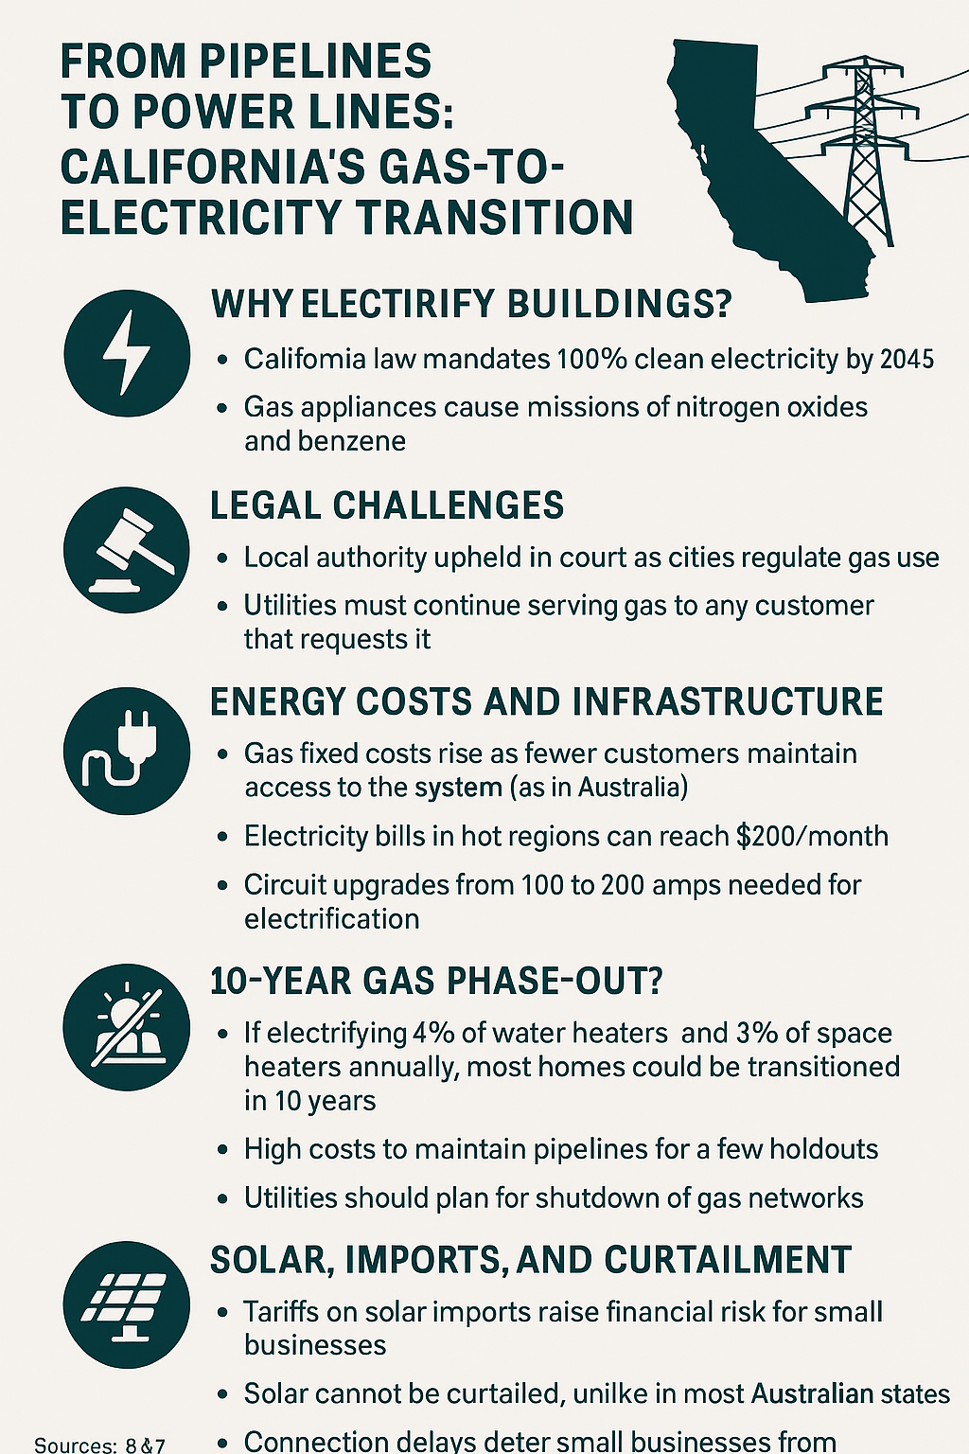
Further Reading
- CPUC Future of Gas Proceeding
- CPUC Utility Costs and Affordability of the grid of the future
- Gridworks Reports
- SB1221 Overview
- Energy Institute Blog (UC Berkeley)
California Energy Commission

Chapter 7: Regulators at the Forefront: How California’s Energy Rules Are Reshaping the Path to Electrification
California is taking a lead in climate and energy policy with Senate Bill 1221 (SB 1221), a law designed to transition the state away from gas infrastructure and toward targeted electrification. At the heart of this ambitious effort is a mix of policy innovation, regulatory engineering, and the deeply practical challenge of mapping and managing the future of energy delivery at the neighborhood level.
Backed by years of analysis and pilot programs, SB 1221 enables utilities to shut down ageing gas pipelines and replace them with electrified heating and cooking infrastructure — if doing so is cheaper than replacing the gas pipe. The legislation requires the California Public Utilities Commission (CPUC) to negotiate the implementation details with utilities like PG&E, which have been quietly electrifying communities. According to David Sawaya of PG&E, “We’ve been electrifying customers on some branch lines for seven years, and our policy is that 100% of customers must buy in. Only 30% of projects therefore get the go-ahead.” In contrast, SB 1221 allows the gas companies to electrify with just 66% of customers on that line buying in.
A Bill with Big Stakes
Co-authored by Beckie Menton of the Building Decarbonization Coalition and implemented with support from CPUC staff like Arthur Fisher, SB 1221 marks a major shift in California’s approach to utility obligations. Arthur Fisher notes, “The act is legislated, so the CPUC is now negotiating the mechanism via a process in front of the commissioners.” This includes rethinking the long-standing "Obligation to Serve" — a policy that has led to costly and counterproductive investments in gas infrastructure.
The bill’s key innovation lies in enabling non-pipeline alternatives (NPAs) to traditional gas line replacement. According to CPUC and NRDC's Kiki Velez, electrification projects under SB 1221 can only proceed if they directly save money for gas customers — by avoiding the cost of new pipeline construction. “These projects can be paid for using the avoided gas pipeline costs while delivering the savings back to customers,” Velez explains.
The Mapping Mandate
One of the most technically complex — and politically sensitive — parts of the bill is its mapping requirement. As Arthur Fisher says, “The map must be submitted by July 2025 and focused on pipe replacement.” Public Utilities Code 661(a) mandates that each gas corporation submit detailed maps annually, showing where gas infrastructure is planned for replacement, and overlaying this with city, county, and census tract boundaries, as well as disadvantaged communities and designated decarbonization zones.
But this mapping has become a sticking point. Rachel Wittman of PG&E, who is overseeing implementation of SB 1221 at the utility, noted that PG&E has already spent four to five years building a GIS-based Geospatial Electrification Tool. “It includes pipe locations, customer bills, fire risk, and upcoming gas work. This should be adequate for optimization in planning.” PG&E prefers that the CPUC adopt its existing mapping methodology, rather than require a completely new framework.
Forcing the Final Third?
One of the most politically charged components of SB 1221 is the mechanism for securing customer participation. While PG&E historically only proceeds with electrification when 100% of customers agree, SB 1221 sets the bar at 66% agreement, leaving the potential for one-third of customers to be “forced” off gas.
Fisher acknowledges the challenge. “Politically, I'm not sure the CPUC would enable a project to move forward with a full one-third of customers objecting.”
Potential solutions include partnering with community-based organizations for outreach, offering free home electrification to sweeten the deal, and allowing holdouts to use backup fuels like propane. But even internally, PG&E concedes it lacks a definitive answer for compelling reluctant participants.
Who Pays for the Transition?
SB 1221 has sparked important debates about cost allocation. At issue is whether electrification upgrades — though cheaper than gas pipes — should be treated as capital assets that earn a regulated return for utilities. PG&E’s proposed CSU Monterey Bay project was withdrawn partly due to disagreement on this point.
As Velez explains, “Almost all stakeholders in California support having the gas utility pay for cost-effective targeted electrification projects. The debate is whether the utility should earn a rate of return.”
The bill is ambiguous on whether these costs should be capitalised. Arthur Fisher and Richard Khoe at CPUC stress that targeted electrification should not burden ratepayers long-term. Assets would be depreciated over shorter periods than gas pipelines, delivering near-term savings.
A Patchwork of Progress
California isn’t alone in confronting the future of gas. NRDC tracks similar efforts in Colorado, Washington, Illinois, New York, and New Jersey. California’s legislation builds on that momentum with more specific mandates and a stronger focus on affordability.
Meanwhile, affordability remains a critical concern. As one community energy aggregator pointed out, “One in ten Californians can’t afford their utility bill.”
Electricity prices are high in California due to wildfire mitigation, old infrastructure, and limited interstate transmission. Distribution costs have surged as utilities harden the grid against fires. The state’s reliance on demand response for summer peaks means prices can spike to $1000/MWh. Gas, by contrast, remains cheap at $3–5 per MMBtu, making the switch harder to sell in the short run.
The Broader System
CPUC handles modeling for resource adequacy and environmental targets, while the California Energy Commission (CEC) leads forecasting and plant licensing. But a disconnect exists between centralized regulators and Community Choice Aggregators (CCAs), who independently procure energy and set local goals.
Some stakeholders — like Clare Holbrook, formerly of PG&E and now at Gridworks — are pushing for improved coordination. Matthew Tisdale, Gridworks’ CEO, has backed initiatives that bridge utilities, regulators, and communities.
The investor-owned gas utility landscape includes PG&E, San Diego Gas & Electric (SDG&E) and Southern Californian Gas (SoCalGas). PG&E serves Northern and Central California, while SoCalGas primarily serves Southern California, and SDG&E serves San Diego County and parts of Orange County. Southwest Gas also provides natural gas distribution in the Lake Tahoe area. The City of Los Angeles runs its own municipal utility for both power and water.
Where to Next?
With a July 2025 deadline looming for the first set of utility maps, the next months will be critical. Rachel Wittman’s PG&E team is expected to publish an economy-wide net zero study showing electrification as the lowest-cost path — but also projecting a 50-year timeline for full transition, with continued need for renewable gas and carbon capture in certain sectors.
And yet, even with legislative authority, technical mapping, and PG&E’s seven years of field experience, questions remain. How do you compel the last holdouts? Should utilities profit from electrification? What’s the right balance between privacy and planning?
As California moves into implementation, the answers will shape the national conversation — and possibly offer models for Australia, where similar debates are emerging.
As Beckie Menton, one architect of SB 1221, and Kiki Velez at NRDC continue to engage stakeholders and fine-tune policy, California once again finds itself as a climate laboratory — experimenting with the tools, incentives, and politics of a post-gas world.

Further Reading:
- NRDC on SB 1221
- CPUC SB1221 Workshop
- NRDC on CO’s Gas Planning
- State Progress Report
- SB1221 full text
- CARB Zero-NOx standards
- Building Decarbonization Coalition
- 350.org USA
- PG&E Electrification Mapping Tool

Conclusion
This international research highlights that Australia is better positioned than California to achieve a successful energy transition — particularly in transmission planning, equitable electrification, and regulatory coordination. While California is a global climate policy leader, Australia’s smaller market, strong state-led initiatives, and coordinated system reforms allow for greater agility.
Six pieces of evidence from the above report support this:
1. Australia's lower electricity prices and higher rooftop solar uptake make electrification more economic.
2. Australia’s state-led electrification roadmaps (e.g. Victoria, ACT) align infrastructure, policy, and community voices.
3. Regulatory harmonisation in Australia enables faster reform than California's fragmented state/federal system.
4. Australia's integrated market design allows for demand flexibility, unlike California's supply-side focus.
5. Early precinct-level planning for gas decommissioning (e.g. ACT, NSW) offers a replicable model..
6. Flexible tariff policies in Australia (e.g. Dynamic Operating Envelopes) outperform California's fixed-rate model.
In sum, Australia can build on its strong foundations and lessons from California to lead the next phase of the global energy transition. The Gill Owen Scholarship enabled critical insight into these pathways, and this report offers a resource for accelerating consumer-centric reform.

